CS512 Assignment 2:Report Prateek Parab

Department of Computer Science Illinois Institute of Technology October 22,2017

# Abstract

This programming assignment deals with corner detection using the Harris corner detection algorithm. Here two images are loaded separately and corner detection algorithm is applied to both the images. Thus feature matching will be done on both the images although the images won’t be exactly same but similar. The corners detected will be displayed in a final image along with the the matched features presented in two separate images. The parameters can be changed using a trackbar functionality.. Corner detection is performed in openCV.

# Problem Statement:

The program should be designed to perform corner detection for a given image. It should load an image by reading it from a test image provided by the user. The user should be allowed to perform manipulation to the image by pressing specific keys on the keyboard such as a help key. It also allows the user to control the feature matching parameters using a trackbar functionality.

# Proposed Solution:

The program is developed to perform corner detection for a specified image. To perform this functions user must press specific keys. The program comprises of loops and a separate algorithm for corner detection other than the inbuilt openCV function. The images have been tested according to their various resolutions and corners are detected and displayed using windows and then the recorded corners are numbered accordingly when they are compared with a similar image which is done by comparing their feature vectors.

# Implementation Details:

In this program corner detection is performed using Harris corner detection. First the window size, corner response and threshold is taken as an input from the user. An offset is calculated based on the window size. Next step is to calculate the derivate in the x direction , y direction and the xy direction. The obtained values are summed up using a summation function in OpenCV. A determinant is calculated along with a trace parameter by add the derivative in x and y direction respectively. Later a corner response value is generated based on the trace and determinant value and also the user input corner response value. If the generated corner response value is greater than the provided threshold then note the corner point and color the point. Thus Harris corner detection is performed

# Results:

# A final image is obtained based on the corner detection operation performed along with matched features. These features are numbered according to their similarities in the respective images. The features are varied by changing few parameters using the trackbar functionality.

# Screenshots:

1. Corners Detected for a test image with variable parameters(Image of hexagons)

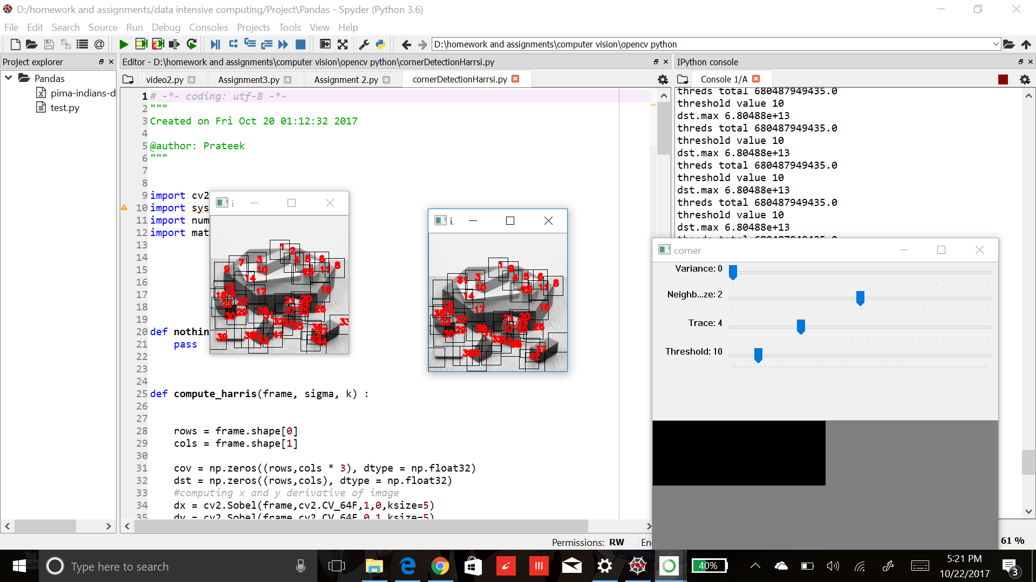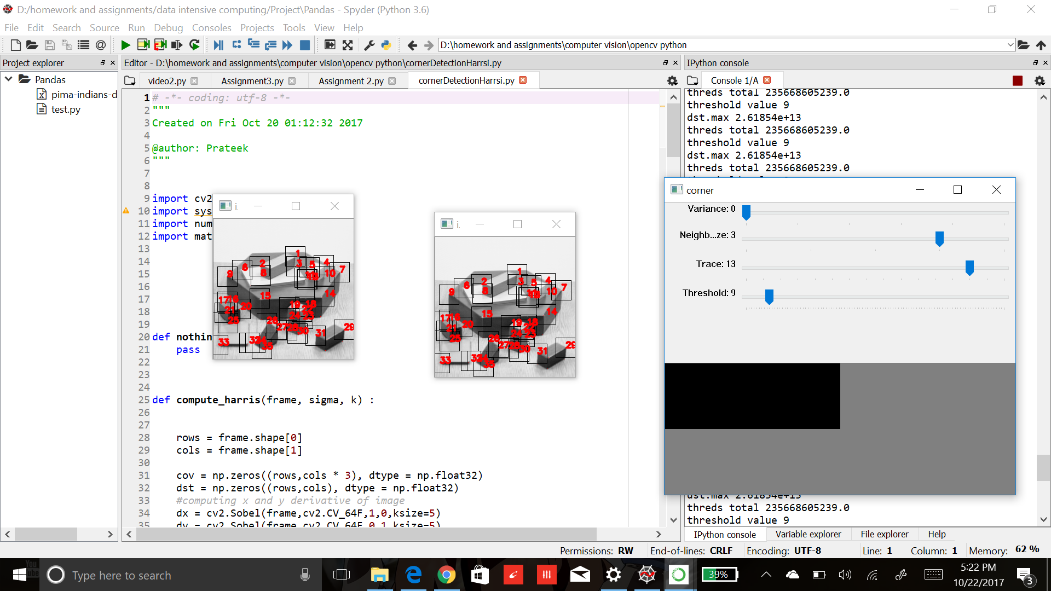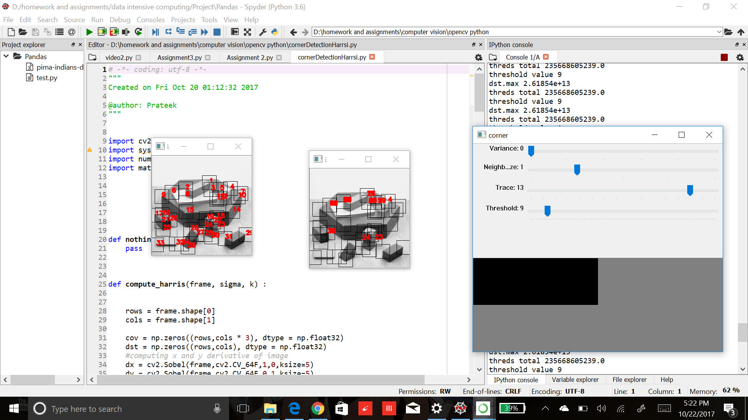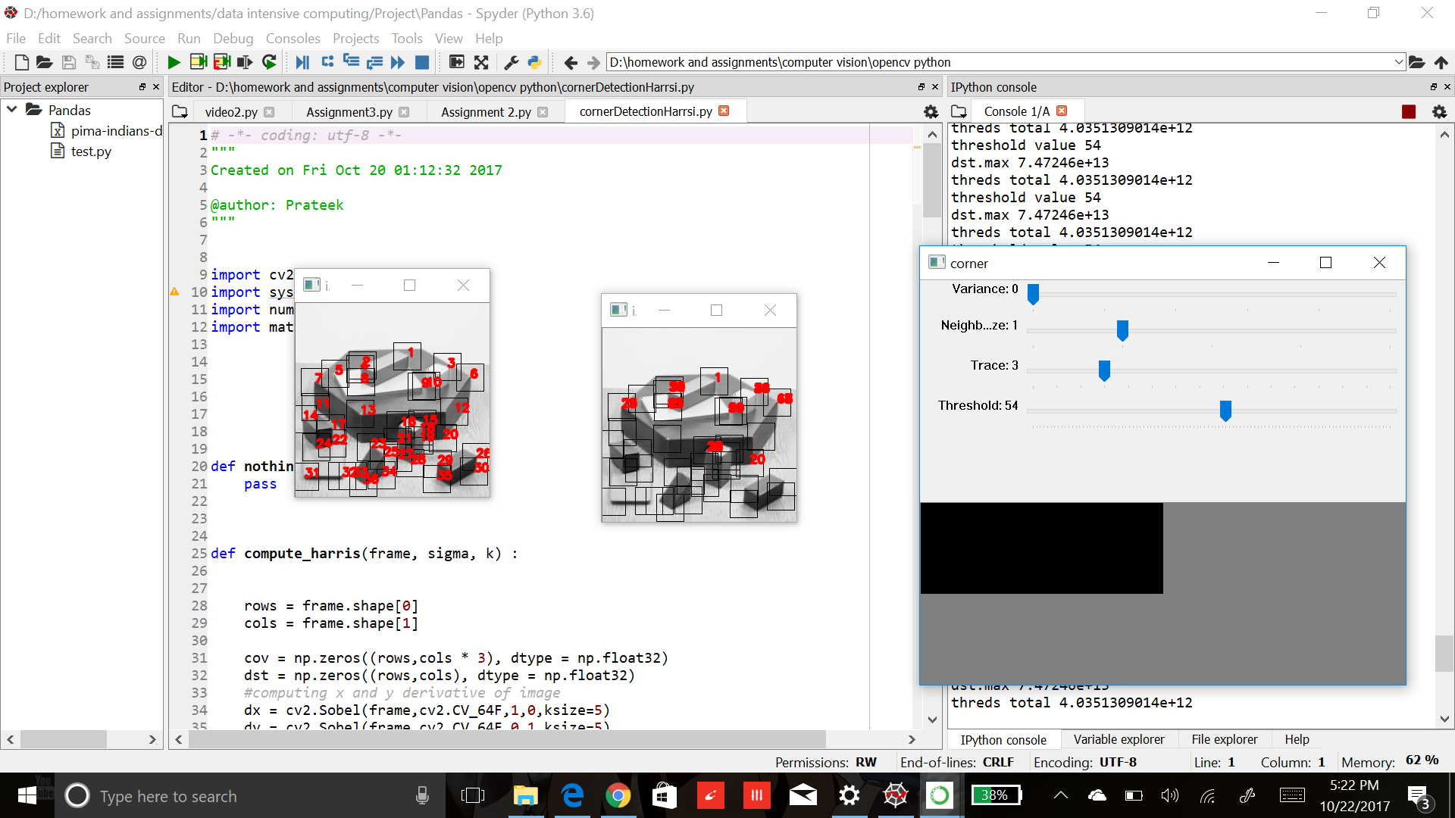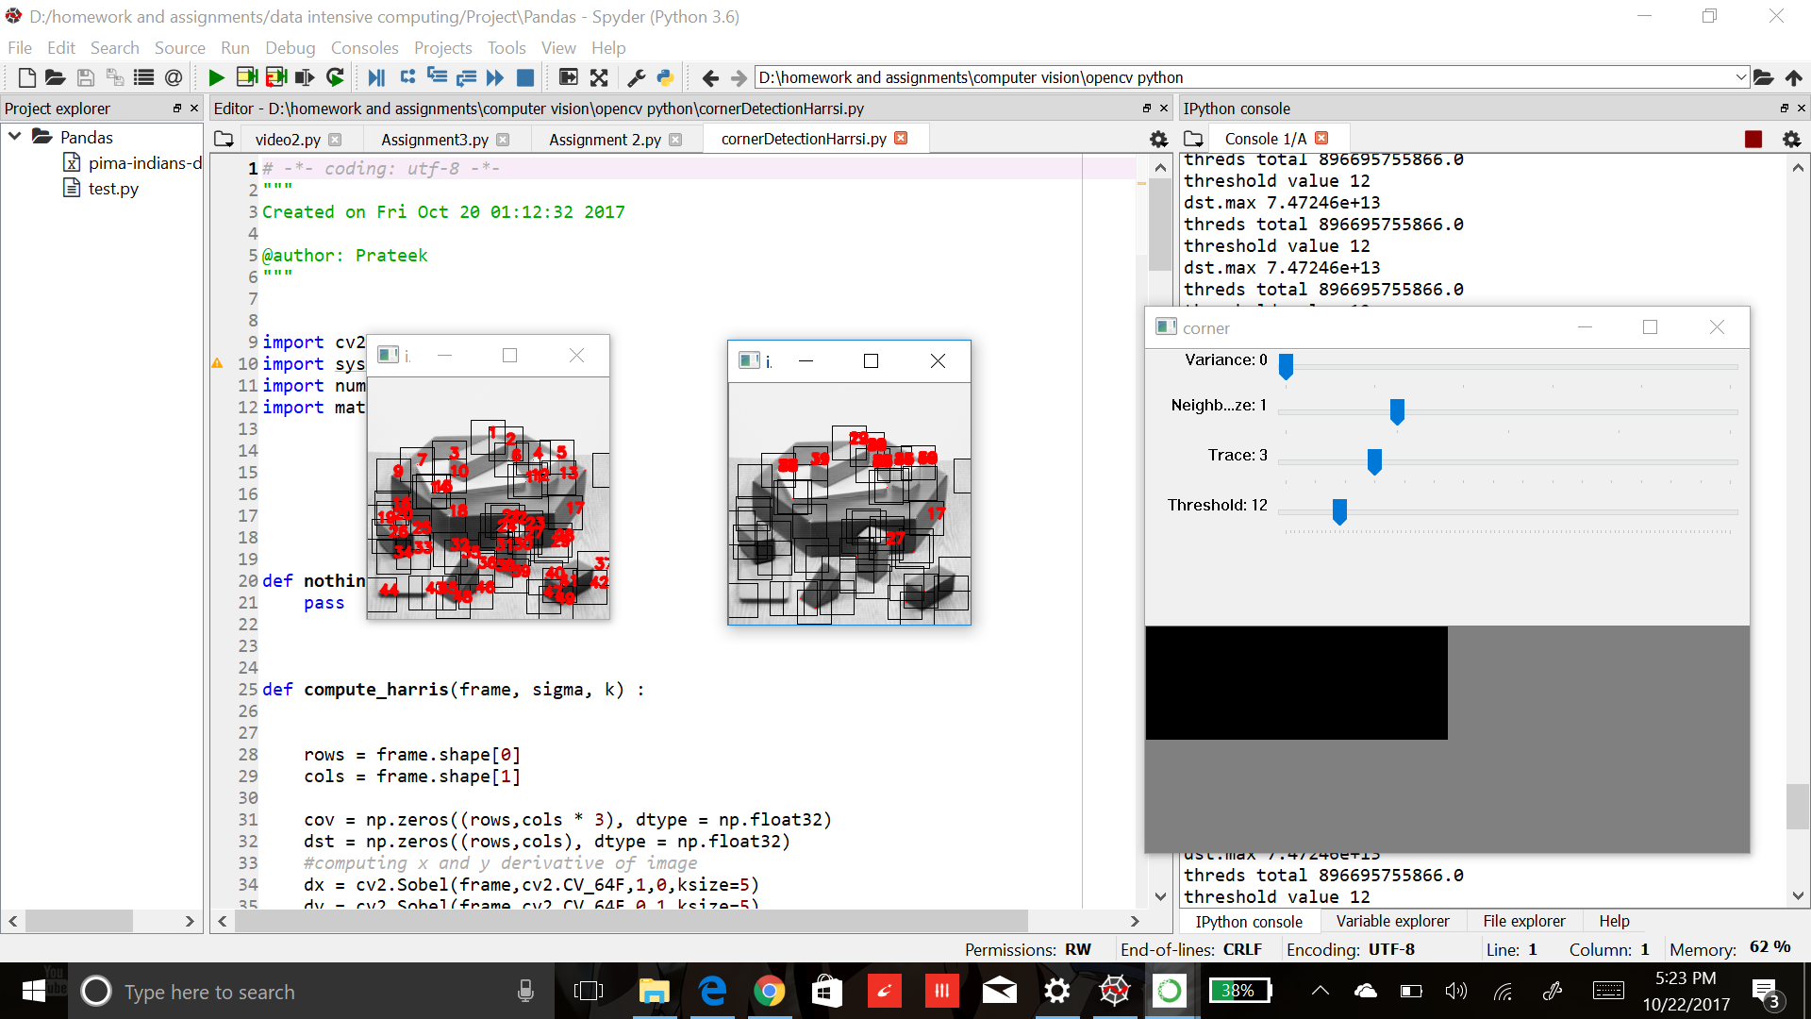

# References:

* 1. **Stack overflow**
  2. **2)opencv.org**

**3)**<http://www>**. meccanismocomplesso.org/en/opencv-python-harris-corner-detection-un-metodo-per-rilevare-i-vertici-in-unimmagine**